

HELP GUIDE

TECHNICAL EMPLOYEE

Login Page

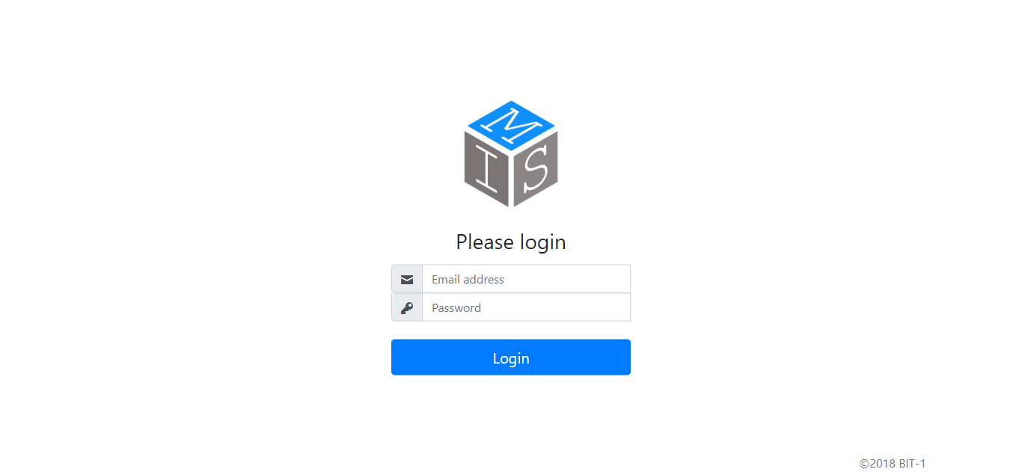

3.Press Login once e-mail, and password has been entered correctly.

2.Enter personal password.

1.Enter business e-mail address.

Dashboard

To get redirected to the page that will allow you to reset your password.

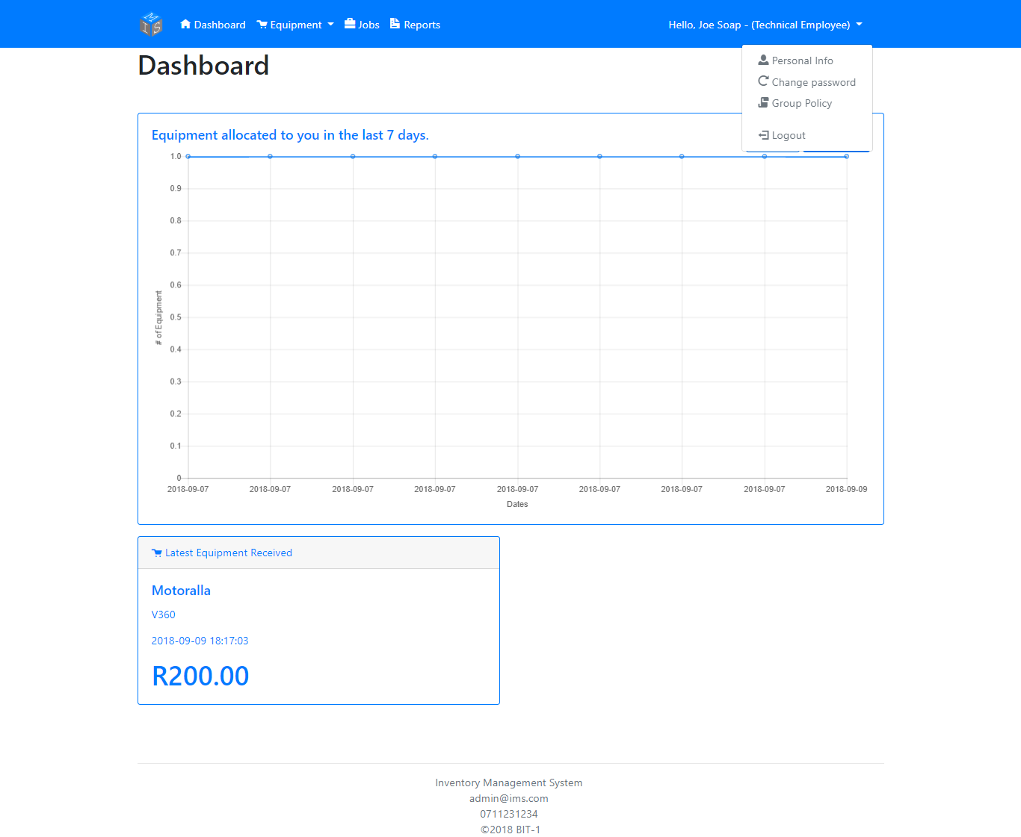

Shows the last equipment received (inputted) by the Section Head.

A PDF involving the business’s Group Policy will get downloaded onto your device.

Graph shows the number of equipment allocated to you in the past amount of filtered days.

To get redirected to the page that will allow you to change your personal details.

Press ‘Filter’ (located behind the ‘Logout’ button) to filter the number of equipment received the last 7, 14, or 30 days. Press ‘Reset’ to return to default.

Update Personal Info

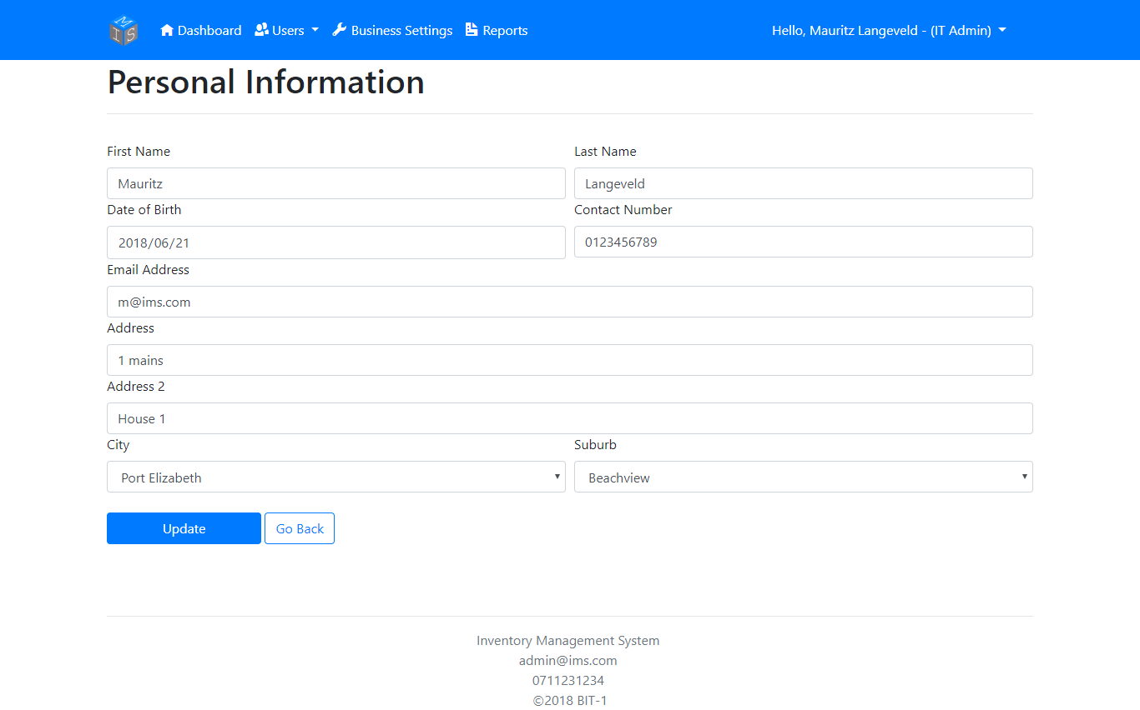

a. Suburb dropdown won’t load unless the user has selected a City.

b. If neither the new user’s City or their Suburb exist in the dropdown, press the ‘Add New City/Suburb’ selection located in the respected dropdown.

Click ‘Update’ to update your personal information.

Change Password

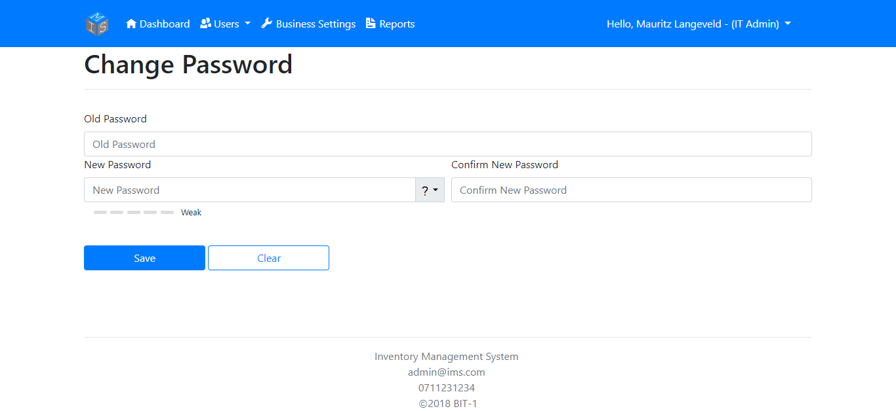

Press ‘Clear’ to erase all fields.

Press ‘Save’ to change your password

Enter your new password here…

Re-enter your new password here…

Enter your current password here…

Install Equipment

If marker isn’t 100% regarding location, you’re able to drag the marker to the desired location.

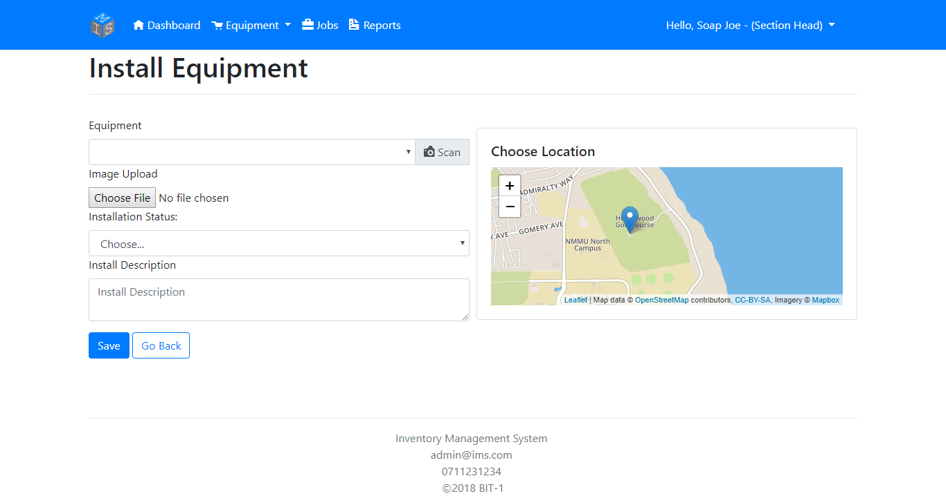

Select the Equipment or scan the equipment’s QR to select the equipment.

You can upload (take a picture if using a smartphone) an image of the equipment’s current condition.

If the map doesn’t load, it’ll be possible that at least one of the following errors might have occurred.

1. Your device has rejected access to your location. To fix, please enable Location on your device/browser.
2. Unable to determine your location.
3. Service timeout regarding connecting to the Mapbox server. To fix, please exit and re-enter the page to try and reconnect to the Mapbox server.
4. Browser not supported (Tested and works on Google Chrome, Mozilla Firefox, and Microsoft Edge. Internet Explorer not supportive.)

Select whether the Installation process is still Open or Closed.

Inspect Equipment

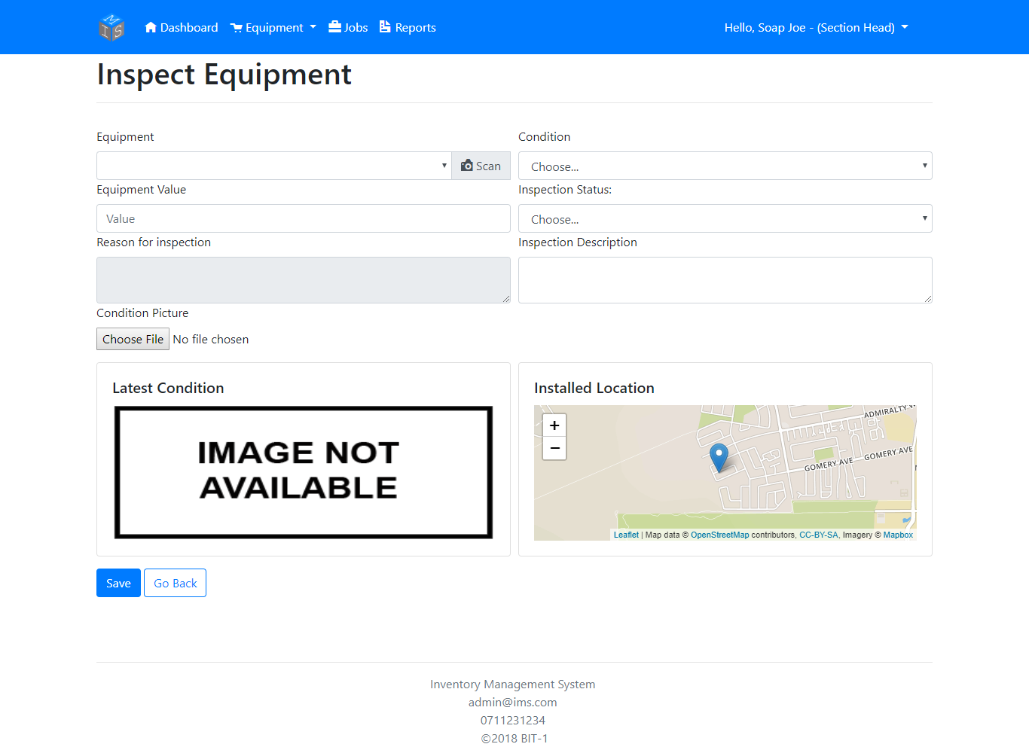

Take a picture or select an image to update the picture of the equipment’s current condition.

Update the Equipment’s value if necessary.

Select to pick the Equipment’s current Condition and to specify whether the Inspection Process is still open or closed.

Select the Equipment or scan the equipment’s QR to select the equipment.

If the map doesn’t load, it’ll be possible that at least one of the following errors might have occurred.

1. Your device has rejected access to your location. To fix, please enable Location on your device/browser.
2. Unable to determine your location.
3. Service timeout regarding connecting to the Mapbox server. To fix, please exit and re-enter the page to try and reconnect to the Mapbox server.
4. Browser not supported (Tested and works on Google Chrome, Mozilla Firefox, and Microsoft Edge. Internet Explorer not supportive.)

Maintain Equipment

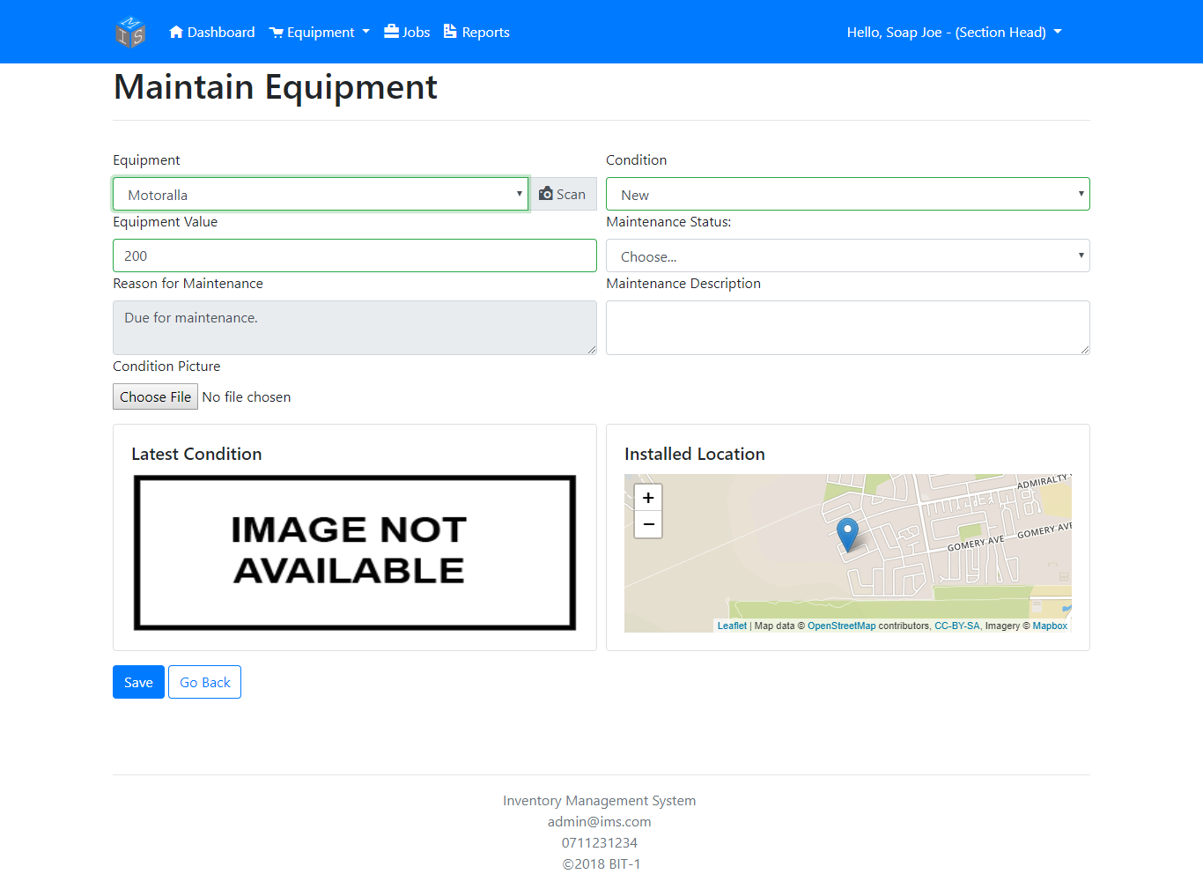

Take a picture or select an image to update the picture of the equipment’s current condition.

Select to update the Equipment’s current Condition.

Select to specify whether the Inspection Process is still open or closed.

Select the Equipment or scan the equipment’s QR to select the equipment.

Update the Equipment’s value if necessary.

If the map doesn’t load, it’ll be possible that at least one of the following errors might have occurred.

1. Your device has rejected access to your location. To fix, please enable Location on your device/browser.
2. Unable to determine your location.
3. Service timeout regarding connecting to the Mapbox server. To fix, please exit and re-enter the page to try and reconnect to the Mapbox server.
4. Browser not supported (Tested and works on Google Chrome, Mozilla Firefox, and Microsoft Edge. Internet Explorer not supportive.)

Allocated Jobs

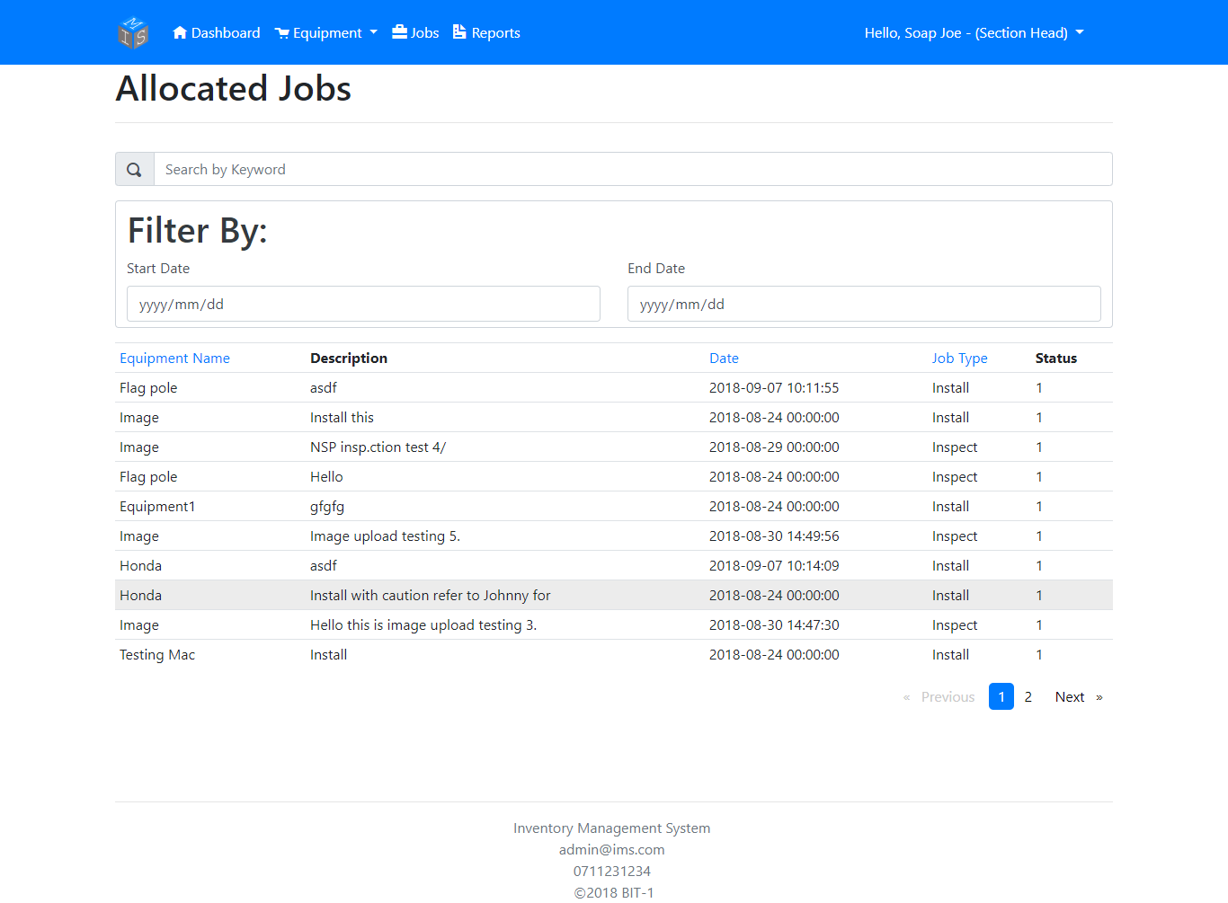

To search for a specific equipment or a type of allocated job by searching using a keyword.

To search for a job between two specific dates.

Generate Report

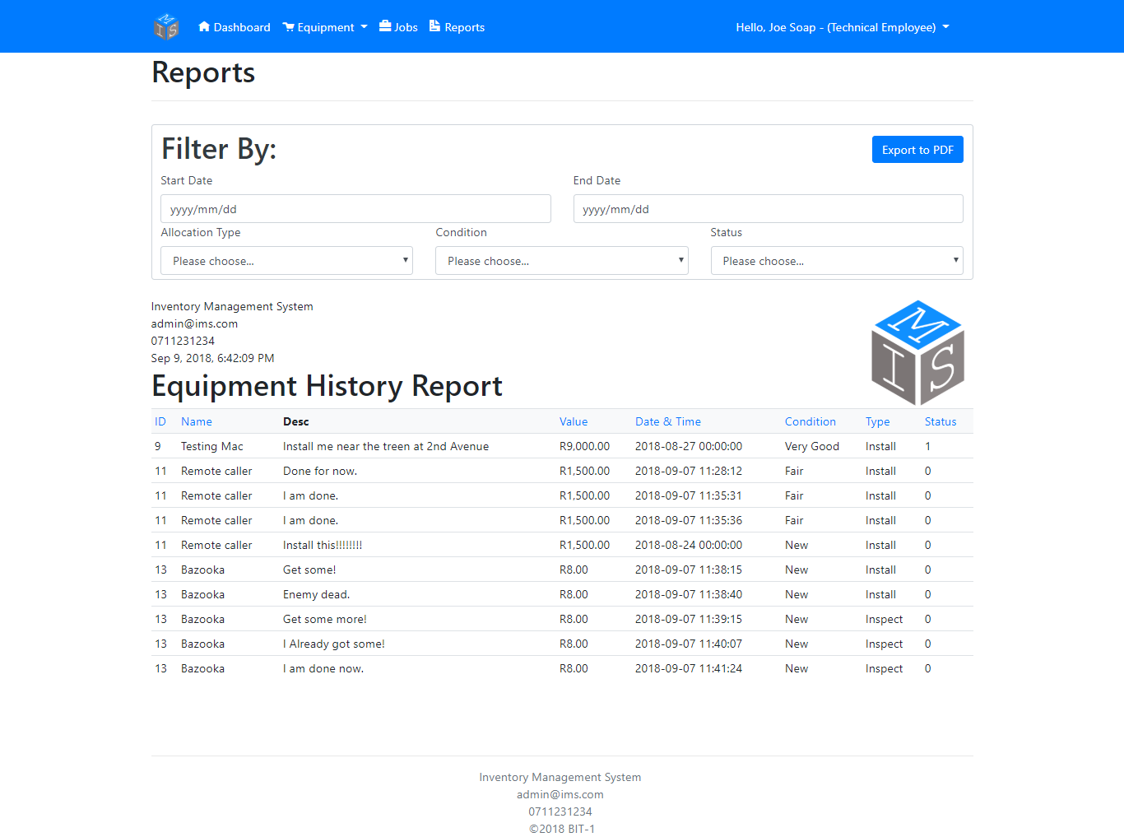

The user can export the Report to a PDF file.

The user can filter the report to be more specific regarding their query.